Regression Analysis: Understanding Relationships and Making Predictions
1. Identifying Relationships Among Variables
Regression analysis is a statistical method used to understand how variables are related to each other. The basic idea is to use historical data to identify potential relationships among variables. By analyzing these relationships, we can predict how changes in one variable might affect another.
Example: Predicting Housing Prices
Imagine you're a real estate analyst trying to predict the price of a house based on various factors like square footage, number of bedrooms, location, and age of the house. You have a dataset of houses sold in the past, with details on each house's price and characteristics.
In this scenario:
- Independent Variables (Predictors): Square footage, number of bedrooms, location (e.g., proximity to city center), and age of the house.
- Dependent Variable (Outcome): The price of the house.
By performing a regression analysis, you can identify how each of these factors (independent variables) is related to the house price (dependent variable). For instance, you might find that:
- For every additional 500 square feet, the price increases by $50,000.
- Houses closer to the city center tend to be more expensive.
- Newer houses generally have higher prices compared to older ones.
2. Using Relationships to Make Predictions
Once you’ve established these relationships using historical data, you can use them to make predictions about future house prices.
Example: Predicting the Price of a New House
Suppose a new house has the following characteristics:
- 2,500 square feet
- 3 bedrooms
- Located near the city center
- Built 5 years ago
Using the relationships identified in your regression model, you can estimate the price of this house. For example:
- Based on square footage: $200,000 (for 2,500 sq ft)
- Add a premium for being near the city center: +$100,000
- Adjust for age: +$20,000
So, the predicted price might be $320,000.
Conclusion
Regression analysis allows you to identify how different variables are related and use these relationships to make informed predictions. Whether predicting housing prices, sales revenue, or any other outcome, regression provides a powerful tool for leveraging historical data to forecast future trends.

Regression Analysis: Understanding and Predicting Relationships Among Variables
1. Estimating Relationships Among Variables
Regression analysis is a statistical method used to estimate and understand the relationships between variables. It is particularly useful when you want to examine how a dependent variable (the outcome you're interested in) is influenced by one or more independent variables (predictors). The goal is to model these relationships numerically to understand how changes in the predictors affect the outcome.
Example: Petrol Prices and Demand
Consider the relationship between petrol prices and demand. You might observe that as demand for petrol increases, petrol prices tend to rise. In this case:
- Dependent Variable: Petrol prices (the variable you want to predict or explain).
- Independent Variable: Demand for petrol (the factor you believe influences petrol prices).
By applying regression analysis, you can quantify this relationship. For instance, the analysis might reveal that for every 10% increase in demand, petrol prices increase by $0.20 per liter. This quantification helps in understanding the strength and direction of the relationship.
Let's elaborate on the example of the relationship between petrol prices and demand using dummy values and visualize it with a graph.
Step 1: Understanding the Variables
- Dependent Variable (Y): Petrol Prices (measured in $ per liter)
- Independent Variable (X): Demand for Petrol (measured in thousands of liters)
Step 2: Creating Dummy Data
Let's assume the following hypothetical data:
Demand for Petrol (X) (in thousands of liters) | Petrol Prices (Y) (in $ per liter)
10 | 1.50
15 | 1.70
20 | 1.90
25 | 2.10
30 | 2.30
35 | 2.50
40 | 2.70
Step 3: Performing Regression Analysis
With this data, we can perform a simple linear regression to quantify the relationship between demand (X) and petrol prices (Y). The regression equation is generally of the form:
Y=mx+ C
Where:
- Y is the petrol price.
- X is the demand for petrol.
- C is the intercept (the expected price when demand is zero).
- m is the slope (the change in price for each unit change in demand).
Based on the dummy data, let’s assume the regression analysis provides the following equation:
Y=1.30+0.04X
Step 4: Interpreting the Results
In this equation:
- The intercept (c = 1.30) indicates that when the demand is 0 (which is theoretical in this case), the petrol price would start at $1.30 per liter.
- The slope (m = 0.04) indicates that for every increase of 1,000 liters in demand, the petrol price increases by $0.04 per liter.
Step 5: Graphical Representation
The relationship can be visualized by plotting the data points and the regression line on a graph.
- X-axis: Demand for Petrol (in thousands of liters)
- Y-axis: Petrol Prices (in $ per liter)
Plotting the Data Points and Regression Line
The data points can be plotted, and a regression line (based on the equation Y=1.30+0.04X) can be drawn to show the trend.
Graph Description:
- X-axis (Demand for Petrol): Ranges from 10 to 40 (in thousands of liters).
- Y-axis (Petrol Prices): Ranges from $1.50 to $2.70 per liter.
The regression line will slope upwards, indicating that as demand increases, petrol prices also increase.
If you were to plot this, the graph would show:
- A set of points scattered in a straight line upward, each point representing the corresponding petrol price at a specific demand level.
- A regression line passing through these points, indicating the overall trend of increasing prices with increasing demand.
This graphical representation makes it easier to visualize how demand impacts petrol prices.
Conclusion
This example and graph demonstrate how regression analysis can quantify the relationship between two variables. The regression equation allows you to make predictions—for example, estimating that if demand rises to 45,000 liters, the petrol price would be:
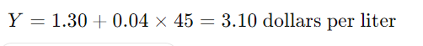
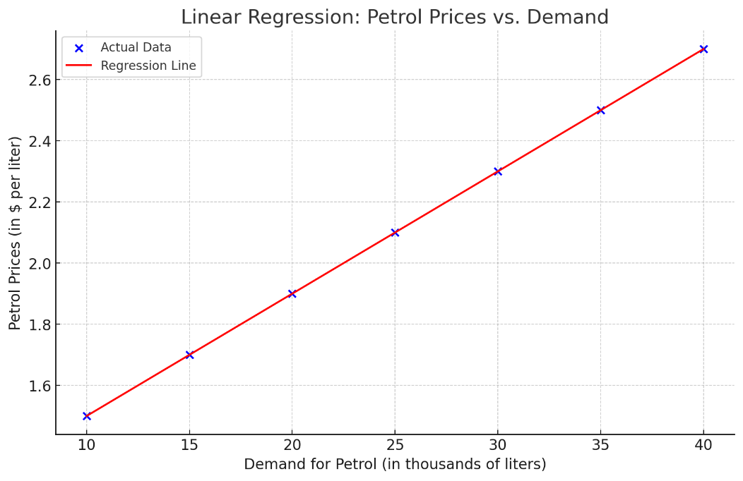

Types of Regression techniques
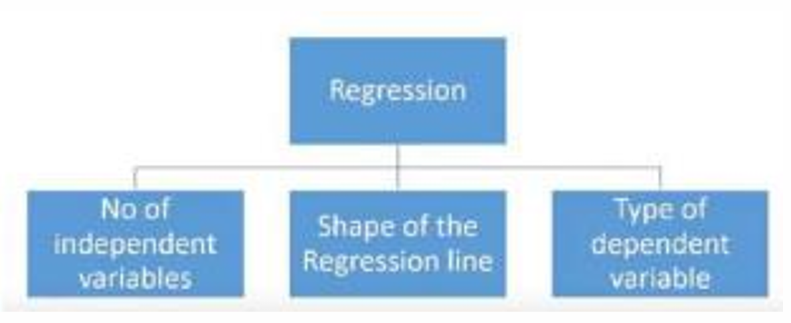
The image you provided shows a simple decision tree diagram for categorizing different types of regression techniques based on three metrics:
- Number of Independent Variables
- Shape of the Regression Line
- Type of Dependent Variable
1. Number of Independent Variables
This refers to whether the regression involves one independent variable (simple regression) or multiple independent variables (multiple regression).
Example:
- Simple Regression: If you are predicting petrol prices based solely on demand, you're using one independent variable.
- Multiple Regression: If you're predicting petrol prices based on demand, crude oil prices, and geopolitical factors, you're using multiple independent variables.
2. Shape of the Regression Line
This refers to the form of the relationship between the independent and dependent variables, which can be linear or non-linear.
Example:
- Linear Regression: If the relationship between demand and petrol prices forms a straight line, it is linear.
- Non-Linear Regression: If the relationship is curved (e.g., quadratic, exponential), it’s non-linear.
3. Type of Dependent Variable
This considers whether the dependent variable is continuous, binary, or categorical, and determines the type of regression used.
Example:
- Continuous Dependent Variable: If you're predicting a continuous outcome like petrol prices, you'd use techniques like linear regression.
- Binary Dependent Variable: If you were predicting whether petrol prices would rise (yes/no), logistic regression would be suitable.
- Categorical Dependent Variable: If you're predicting categories (e.g., "Low", "Medium", "High" petrol prices), you'd use multinomial or ordinal regression.
Conclusion
These three metrics guide the choice of regression technique, depending on the nature of your data and the relationship you aim to model. By understanding these factors, you can select the most appropriate regression method for your analysis.

Understanding the Benefits of Regression Analysis with a Simple Example
Regression analysis is a powerful statistical tool that helps in understanding the relationships between variables and making informed decisions. Let's break down the benefits mentioned using a simple example.
Scenario: Analyzing the Impact of Advertising and Price on Sales
Imagine you're a data analyst working for a company that sells soft drinks. The company wants to understand how its sales are affected by the amount of money spent on advertising and the price of the soft drinks.
Benefits of Regression Analysis
- Indicates the Significant Relationships between Dependent and Independent Variables:
  - Example: The company wants to know if there is a significant relationship between the amount spent on advertising (independent variable) and sales (dependent variable). By performing regression analysis, you might find that there is a strong positive relationship between advertising spend and sales, meaning that increasing the advertising budget is likely to increase sales.
- Indicates the Strength of Impact of Multiple Independent Variables on a Dependent Variable:
  - Example: In addition to advertising, you want to understand how the price of the soft drinks (another independent variable) affects sales. Regression analysis will help you determine how much each variable (advertising spend and price) impacts sales. For instance, you might find that while advertising has a significant positive impact, higher prices may decrease sales. The analysis might show that for every $1,000 increase in advertising, sales increase by 500 units, while a $0.50 increase in price decreases sales by 200 units.
- Helps Compare the Effects of Variables Measured on Different Scales:
  - Example: Advertising spend is measured in dollars, while price changes are measured in cents. Regression analysis helps to compare the effects of these variables, despite being on different scales. This is done by standardizing the variables or by interpreting their coefficients in a comparable way.
- Evaluates the Effects of Price Changes and the Number of Promotional Activities:
  - Example: If the company runs various promotions, regression analysis can evaluate how different types of promotions (like discounts or buy-one-get-one-free offers) affect sales. You can include these promotional activities as independent variables in your regression model to see which type of promotion is most effective in boosting sales.
- Benefits Market Researchers / Data Analysts / Data Scientists:
  - Example: As a data analyst, you can use regression analysis to determine which factors are most important in predicting sales. By identifying and focusing on the key variables (like advertising spend and price), you can build more accurate predictive models. This helps the company allocate resources more efficiently, such as increasing the advertising budget or optimizing pricing strategies, to maximize sales.
Conclusion
Regression analysis is a valuable tool that helps businesses understand the relationships between different variables and make data-driven decisions. By quantifying these relationships, companies can predict outcomes like sales and optimize their strategies to achieve better results.

Question
What is simple linear regression? State how to use simple linear regression with its relevant formula ?

Numerical are also very important

What is multiple linear regression? state how to use multiple linear regression with its formula? explain with the help of house price prediction example

Question
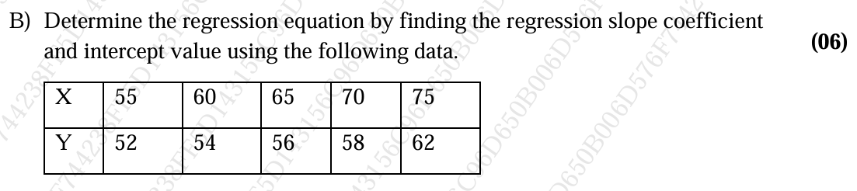
Solution:
Step 1: Calculate the Means
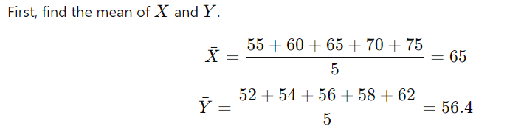
Step 2: Calculate the Slope $b_{1}$
The slope $b_{1}$is calculated using the formula:
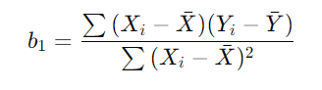

Let's calculate the numerator and the denominator separately.
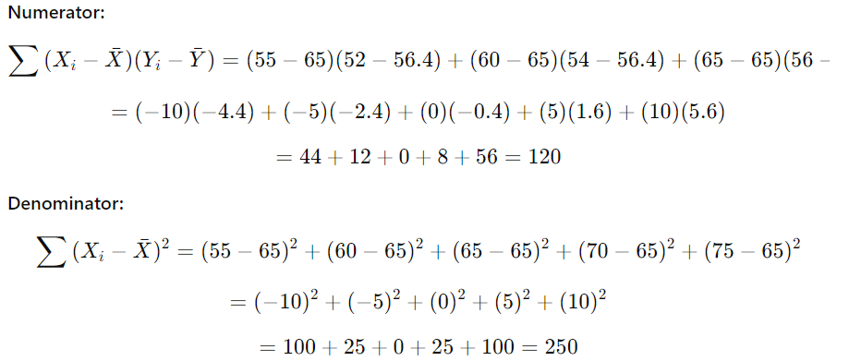
The slope $b_{1}$ is:
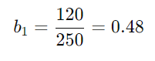
Step 3: Calculate the Intercept $b_{0}$
The intercept $b_{0}$ is calculated using formula
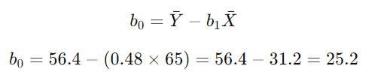
Step 4: Write the Regression Equation
The regression equation is:
